Year 12 Examination, 2016

Question/Answer Booklet

MATHEMATICS SPECIALIST

Section One: Calculator-free

Student Name/Number: ______________________________________________

Teacher Name: ______________________________________________

Time allowed for this section
Reading time before commencing work: five minutes
Working time for this section: fifty minutes

Materials required/recommended for this section
To be provided by the supervisor: This Question/Answer Booklet
Formula Sheet

To be provided by the candidate:
Standard items: pens (blue/black preferred), pencils (including coloured), sharpener,
correction fluid/tape, eraser, ruler, highlighters
Special items: nil

Important note to candidates
No other items may be taken into the examination room. It is your responsibility to ensure that you do not have any unauthorised notes or other items of a non-personal nature in the examination room. If you have any unauthorised material with you, hand it to the supervisor before reading any further.

Section One: Calculator-free 35% (54 Marks)

This section has seven (7) questions. Answer all questions. Write your answers in the spaces provided.

Spare pages are included at the end of this booklet. They can be used for planning your responses and/or as additional space if required to continue an answer.
- Planning: If you use the spare pages for planning, indicate this clearly at the top of the page.
- Continuing an answer: If you need to use the space to continue an answer, indicate in the original answer space where the answer is continued, i.e. give the page number. Fill in the number of the question that you are continuing to answer at the top of the page.

Suggested working time: 50 minutes.

Question 1 (8 marks)

- If find the values of and , where and are real constants.
(3 marks)

- The complex number is transformed to its reciprocal .

- What is the reciprocal of in the form ? (2 marks)

- State the reciprocal of in polar form. (2 marks)

- Given z is a complex number, express the modulus and argument of in terms of and . (1 mark)

Question 2 (8 marks)

Let and . Determine the following:
- and its natural domain. (2 marks)

- and its natural domain and range. (3 marks)

- Sketch on the axes below showing all major features. (3 marks)

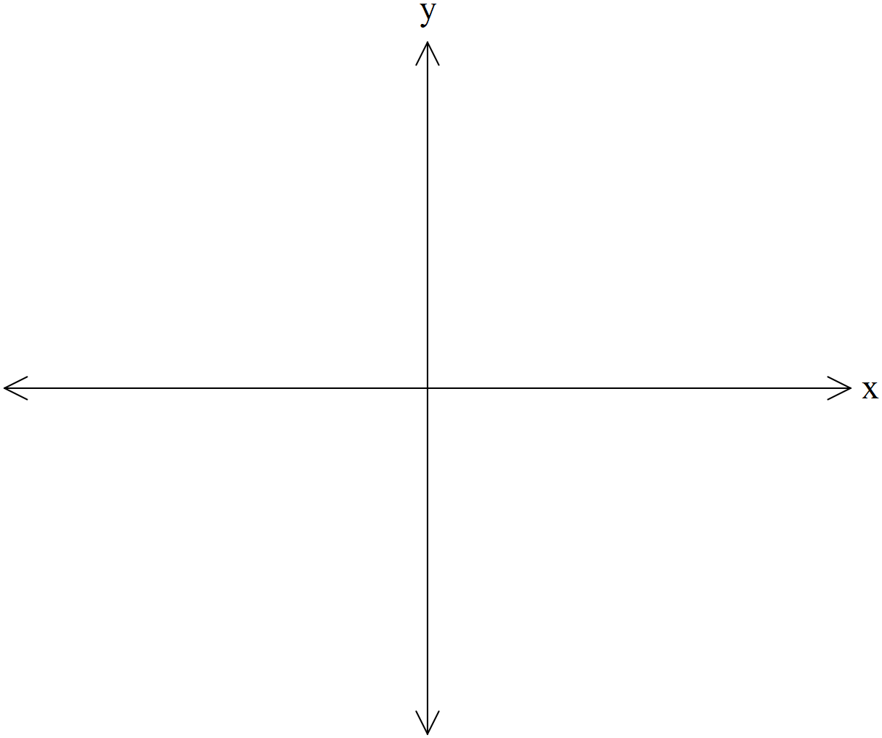

Question 3 (5 marks)

Consider the function as graphed below:
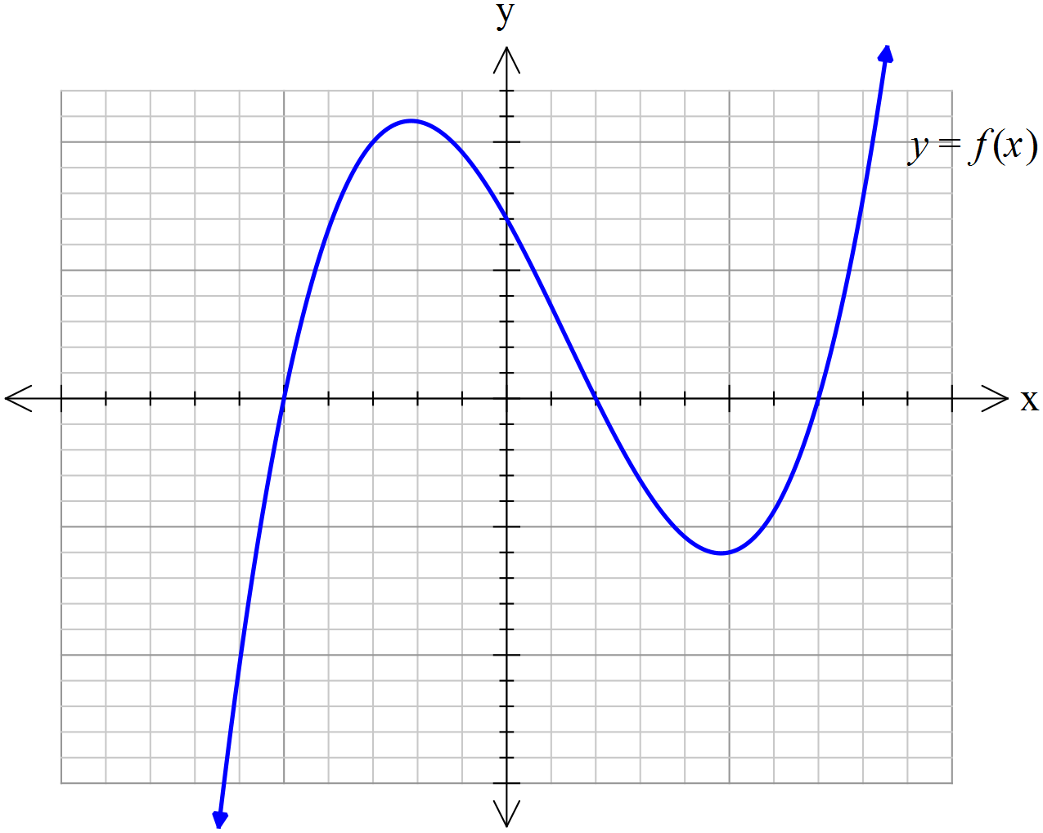

On the set of axes provided, sketch the new curve given that the dotted curve is .
- Sketch . (2 marks)
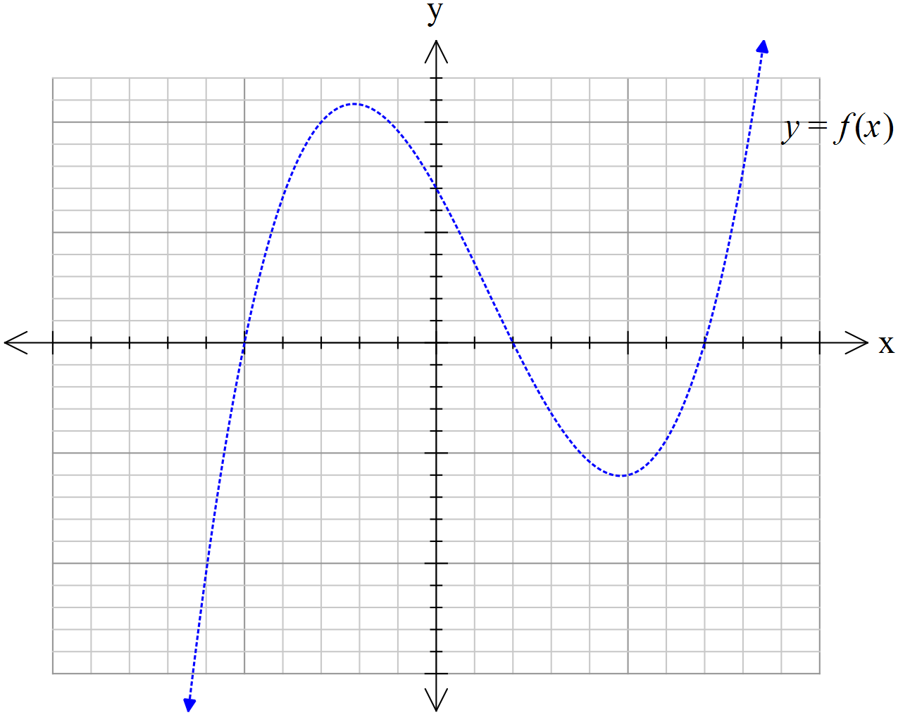

Question 3 (continued)

- On the axes below, sketch . (3 marks)


Question 4 (11 marks)

Determine the following integrals.
- (2 marks)

- (3 marks)

Question 4 (continued)

Determine the following integrals with the given substitution.

- (3 marks)

- (3 marks)

Question 5 (8 marks)

Consider the following system of linear equations:

$$\begin{matrix}x+2y+3z=2 \\ 3x+7y+11z=6 \\ x+y+az=b\end{matrix}$$

where $x,y$and $z$ are the unknowns and $a$ and $b$ are constants.

- For which values of the constants $a$ and $b$ is there no solution? (4 marks)

- Solve the equations given that $a=5$ and $b=3$. (3 marks)

- For which values of the constants $a$ and $b$ are there precisely two solutions? (1 mark)

Question 6 (6 marks)

The Cartesian equation of a sphere $S$ is

$$x^{2}+y^{2}+z^{2}=2x+4y-4z$$

- By rearranging the equation in the form ${(x-a)}^{2}+{(y-b)}^{2}+{(z-c)}^{2}=r^{2},$ determine the coordinates of the centre C of $S$and its radius. (2 marks)

- Show that the origin O lies on $S$. (1 mark)

- Find the coordinates of the point A on $S$ that is diametrically opposite to O. (1 mark)

- Find the Cartesian equation of the plane $P$ which contains the point A and is tangent to $S$.
Hint: The radial vector $\vec{OC}$is normal to $P$. (2 marks)

Question 7 (8 marks)

- From the differential equations provided, select and state the one that matches each respective slope field drawn below. (3 marks)
i)
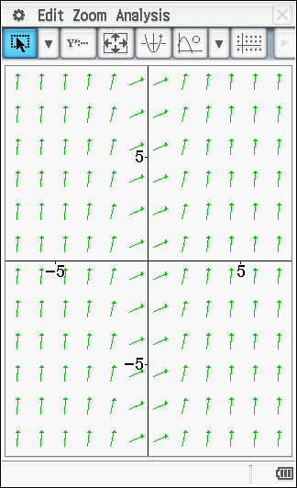

ii)
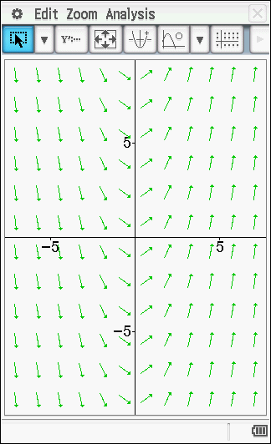

iii)
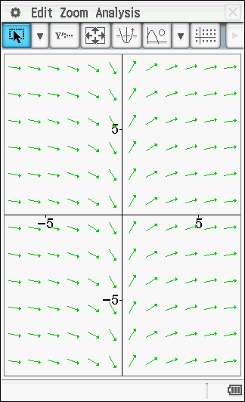

Question 7 (continued)
- Consider the slope field for
- For what values of and will ? (1 mark)

- For what values of and will ? (1 mark)

- On the axes below, sketch the slope field for (3 marks)

